|  |
| --- |
| HENAO games |
| Henao Games Prototype #1 |
| **Our First Mobile Game!**   |
| Version #0.1  All work Copyright © 2021 by XX Games.  All rights reserved. |
| **Emmanuelle Henao** |
|  |

|  |
| --- |
| October 2nd 2023 |

**Table of Contents**

[Your Table of Contents should go here. Make sure that your document’s sections are hyperlinked to their corresponding pages.]

1. Game Description
2. Gameplay Mechanics
3. Controls
4. Interface Sketches
5. Screen Descriptions
6. Game World
7. Levels
8. Characters
9. Enemies
10. AI
11. Attacks
12. Scoring
13. Sound Index
14. Art Index
15. Design Notes
16. Future Features

**Version History**

[This is where you keep track of the detailed changes made to your document throughout the course of development.]

October 2nd – Added All menu functionality and conglomerated all assets (art,sound, bg music etc.)

[This is the body of your video game design document. You should add and delete sections as they pertain to your game’s design.]

1. **Game Description**

*Henao Games is a Vampire Survivor-like game where the main character will be swarmed by enemies and they will need to survive by attacking.*

1. **Game Play Mechanics**

*The enemy waves will increase faster as time goes on, and the players score will be determined by the number enemies killed and the amount of time survived. The player will be able to move and directionally aim their attack*

1. **Controls**

*As a mobile game, our only controls will go through a touch screen, with a digital analog stick to move around and another digital analog stick to indicate direction of attack*

1. 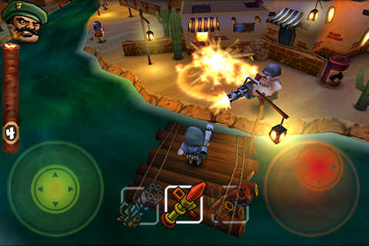**Interface Sketch**

*The Interface will look somewhat similar to this screenshot.*

1. **Menu and Screen Descriptions**

*These screenshots are simply placeholder but they depict the basic idea behind the Menu UI*

1. **Game World**

*Classic Forest style area similar to Pokemon Starting area, the longer we play the game, the more serious and dark the game world will look*

1. **Levels**

*After surviving for X amount of time, the level will “transition” into the next stage where other unique enemies will be presented*

1. **Characters**

*There is one main character available , with potential expansion capabilities to offer alternate options for playstyles.*

1. **Enemies**

*TBD at a later date*

1. **AI**

*The AI for most enemies will most likely be fairly simple of chasing down the the Main Character. There may be some enemies who will not chase but rather shoot projectiles from afar.*

1. **Attacks**

*The main character will only have one type of attack, most likely to be a sword swing (can be changed depending on game feel). If multiple characters are introduced, then each character will have their own unique attack*

1. **Scoring**

*Scoring is calculated in two ways, through time survived and enemies killed. The nuance of the score can be determined at a later date.*

1. **Sound Index**

*Please see the following link for any sound inquiries* [*https://jdwasabi.itch.io/8-bit-16-bit-sound-effects-pack*](https://jdwasabi.itch.io/8-bit-16-bit-sound-effects-pack)

1. **Art / Multimedia Index**

*Please see the following link for any sound inquiries* [*https://game-endeavor.itch.io/mystic-woods*](https://game-endeavor.itch.io/mystic-woods)

1. **Design Notes**

*TBD*

1. **Future Features**

*TBD*